chicks
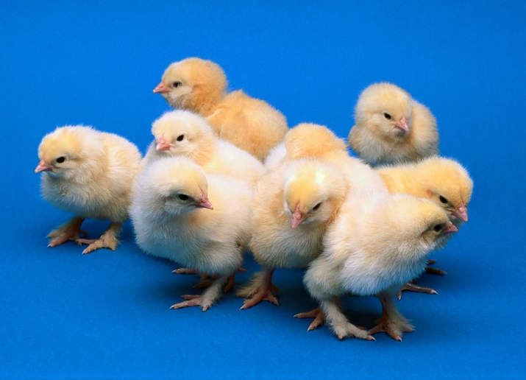
duck
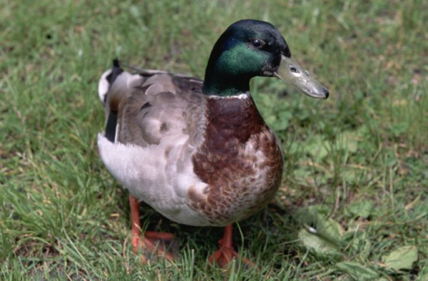
cow
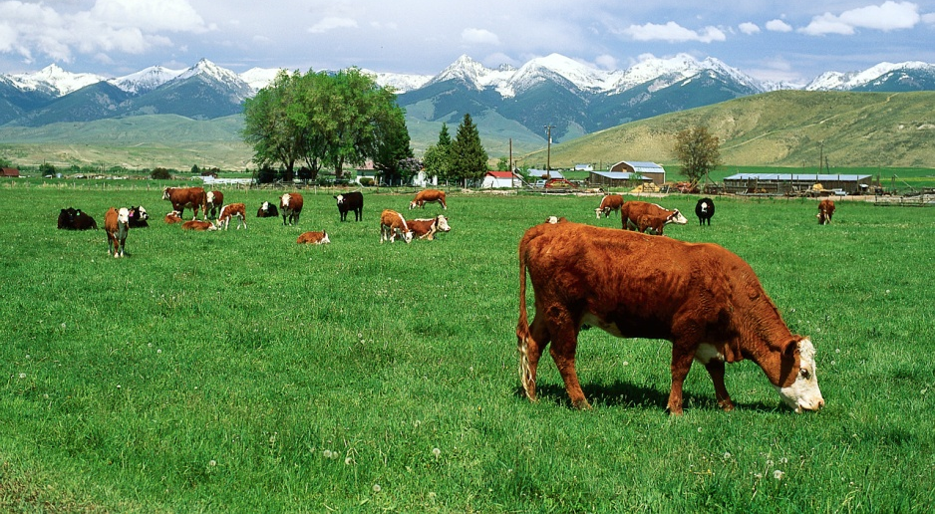
turkey
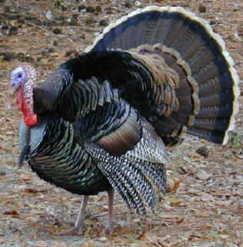
pig
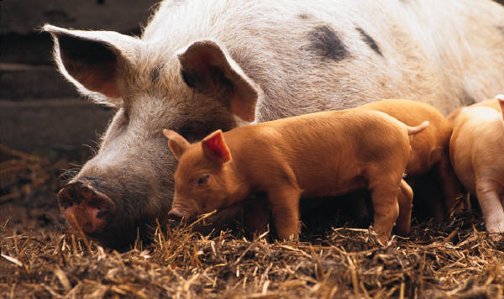
donkey
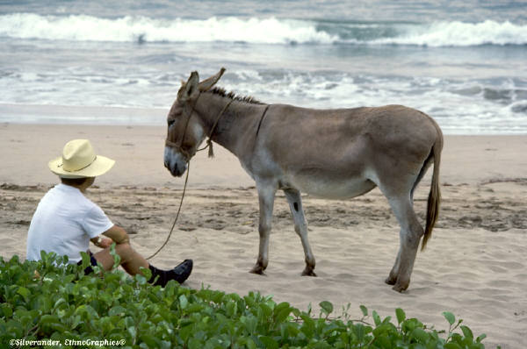
Printing 4x6 index cards—either portrait or landscape
1. FilePage Setup
a. Margins
1) Your choice: .5” to .2” works well
2) Orientation: either portrait or landscape
b. Paper
1) Paper size: 4x6
2. Make your cards (Comic Sans MS is a good font to use)
3. PrintProperties
a. Main-->Media Type: Matte Photo Paper
b. Page SetupPage Size: 4x6 (orientation: keep portrait)
c. OKPut your index card in the printer portrait orientation

