**Aa**



**apple**

**Bb**

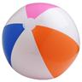

**ball**

**Cc**

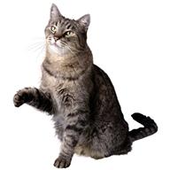

**cat**

**Dd**

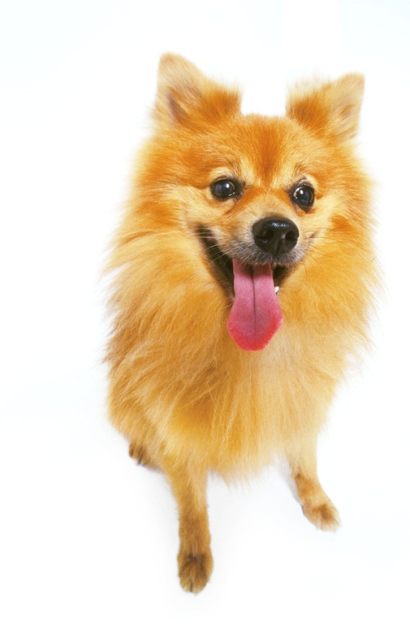

**dog**

**Ee**

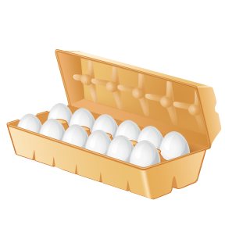

**eggs**

**Ff**

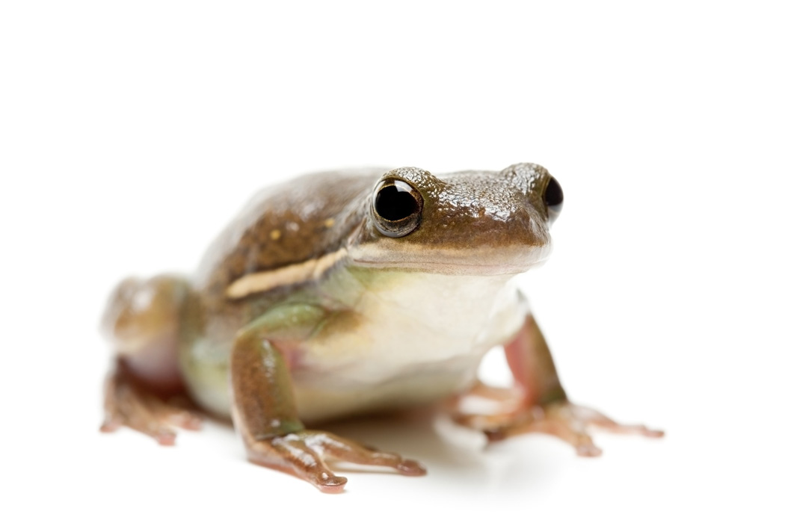

**frog**

**Gg**

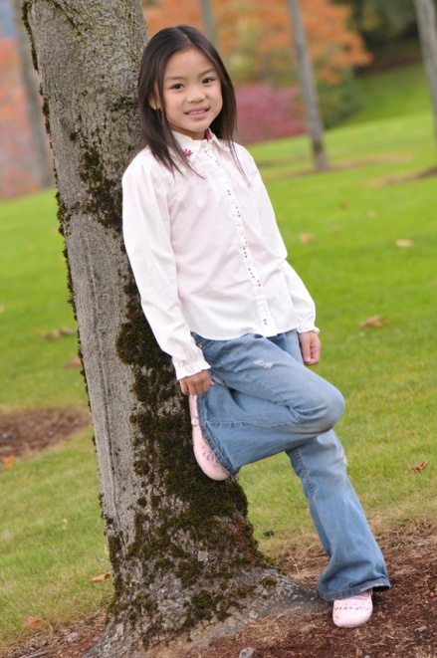

**girl**

**Hh**

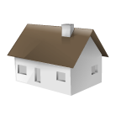

**house**

**Ii**

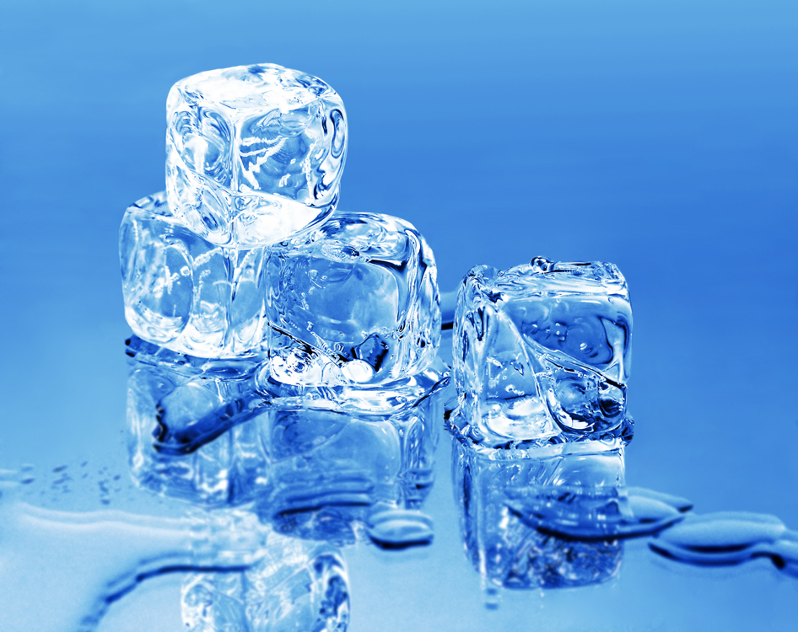

**ice**

**Jj**

[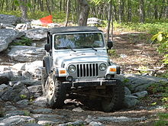](http://en.wikipedia.org/wiki/File:Rockcrawling.JPG)

**jeep**

**Kk**

[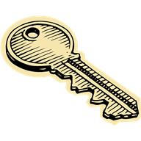](javascript:void(0))

**key**

**Ll**

[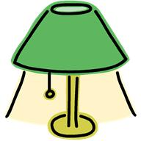](javascript:void(0))

**lamp**

**Mm**

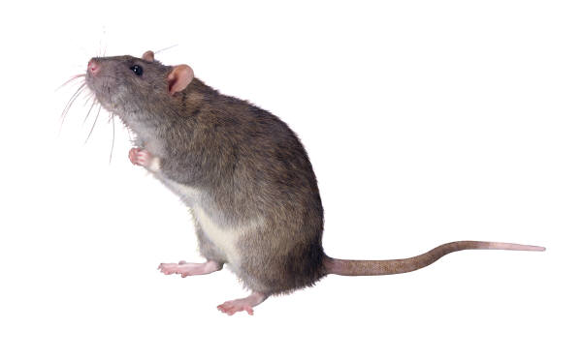

**mouse**

**Nn**

[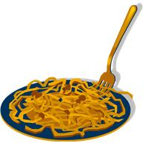](javascript:void(0))

**noodles**

**Oo**

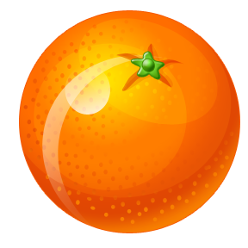

**orange**

**Pp**

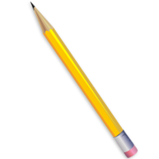

**pencil**

**Qq**

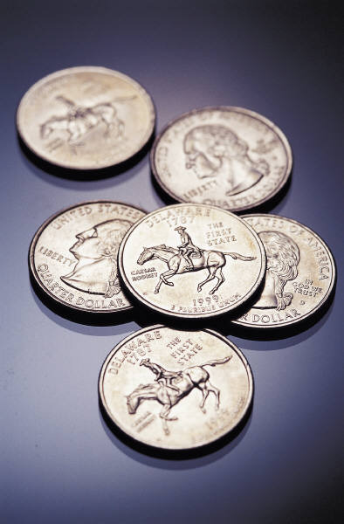

**quarters**

**Rr**

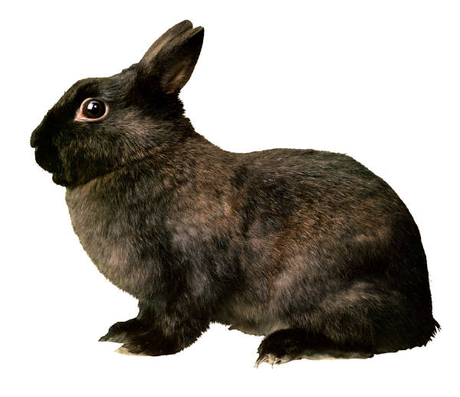

**rabbit**

**Ss**

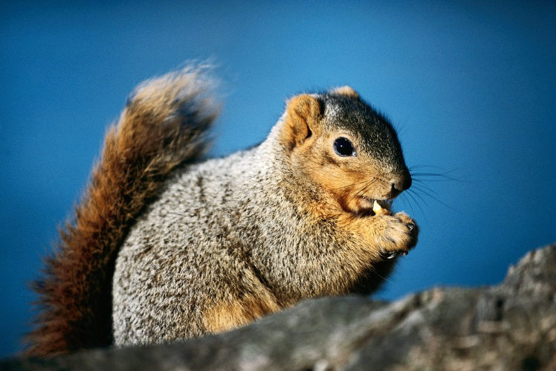

**squirrel**

**Tt**

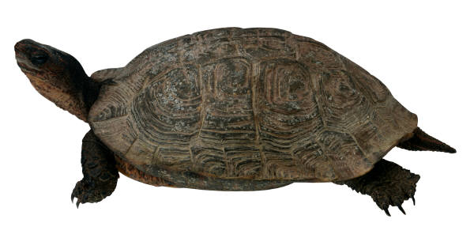

**turtle**

**Uu**



**umbrella**

**Vv**

[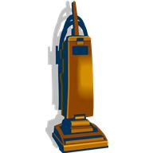](javascript:void(0))

**vacuum**

**Ww**

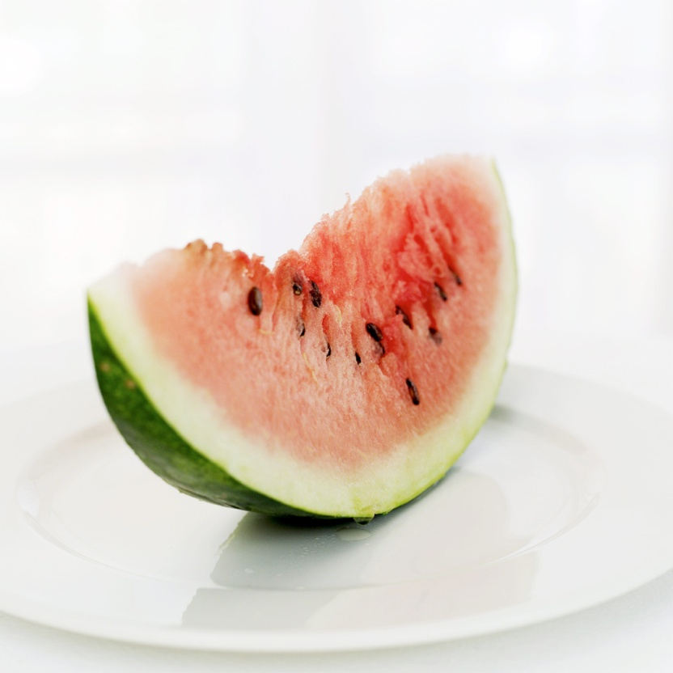

**watermelon**

**Xx**

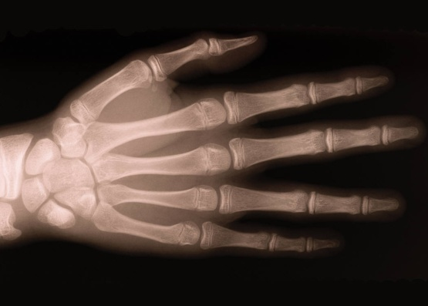

**x-ray**

**Yy**

[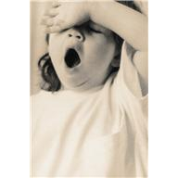](javascript:void(0))

**yawn**

**Zz**

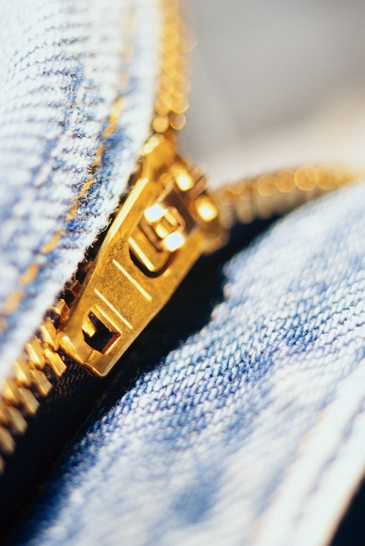

**zipper**

**1. Write your name on one index card.**

**2. In one word describe your most relaxing image. Put this word on another index card.**

**Word**

**Wall**